**Assignment 2 (Continued) 28-03-2024**

1. Change the name of Salesman_Master to Sman_mast

alter table Salesman_Master_114 rename to Sman_mast;

desc Sman_mast;

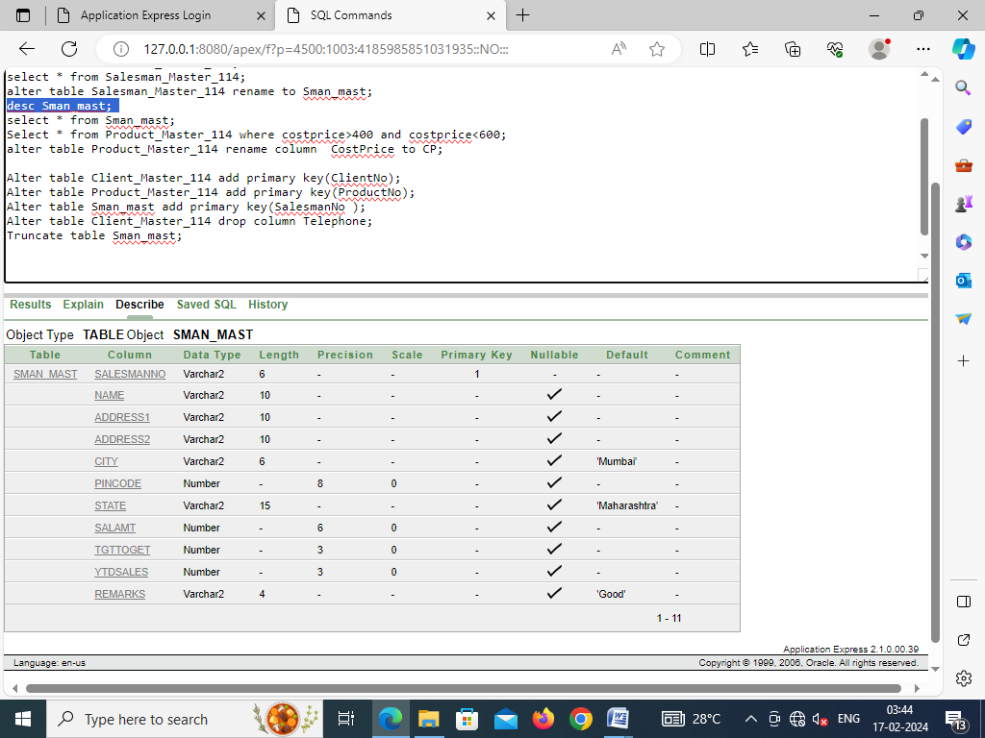

1. Display those products whose cost price is between 400 and 600

Select * from Product_Master_114 where costprice>400 and costprice<600;

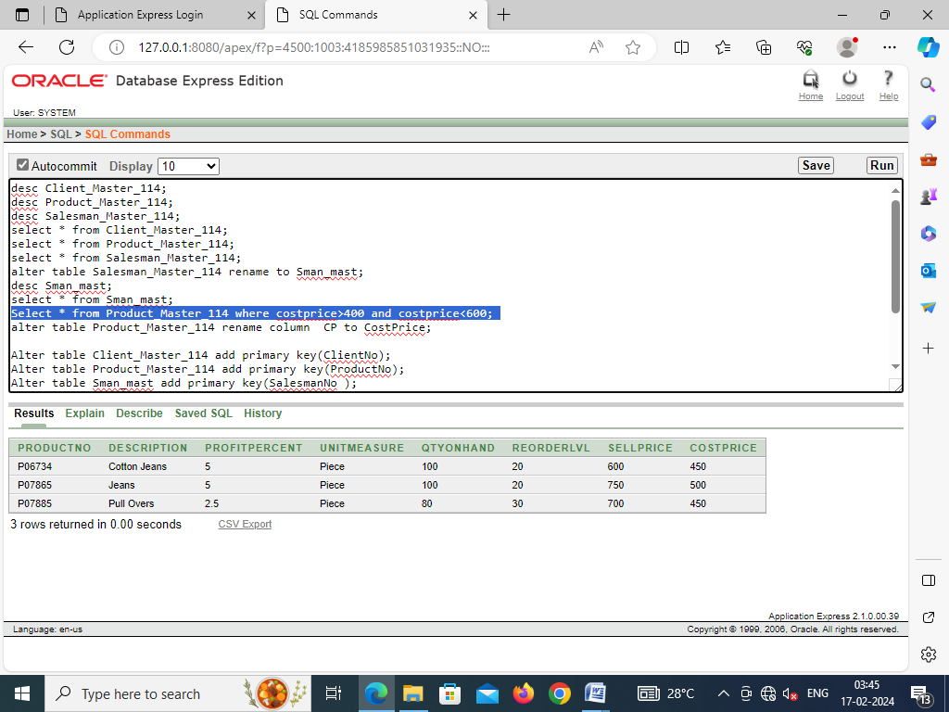

1. Change the name of the field cost price of Product_Master table to CP

alter table Product_Master_114 rename column CostPrice to CP;

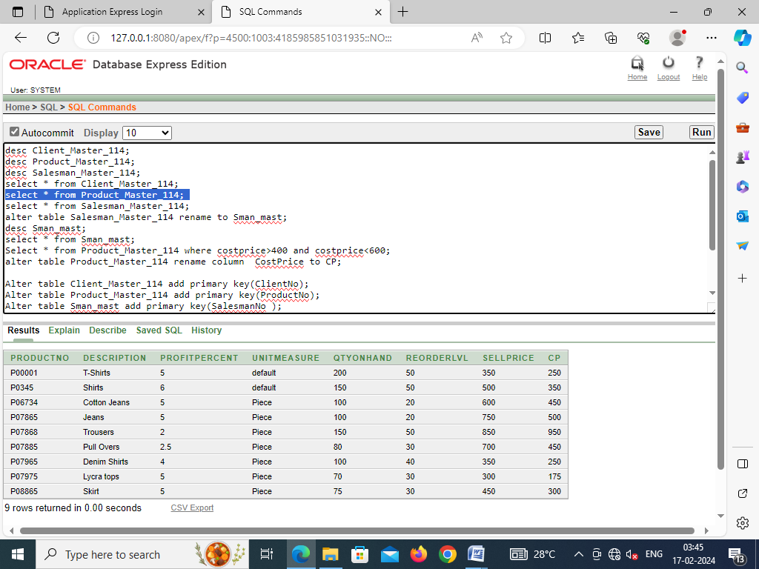

1. Assign ClientNo, ProductNo and SalesmanNo as the primary key for the three tables Clent_Master, Product_Master and Sman_mast respectively.

Alter table Client_Master_114 add primary key(ClientNo);

Alter table Product_Master_114 add primary key(ProductNo);

Alter table Sman_mast add primary key(SalesmanNo );

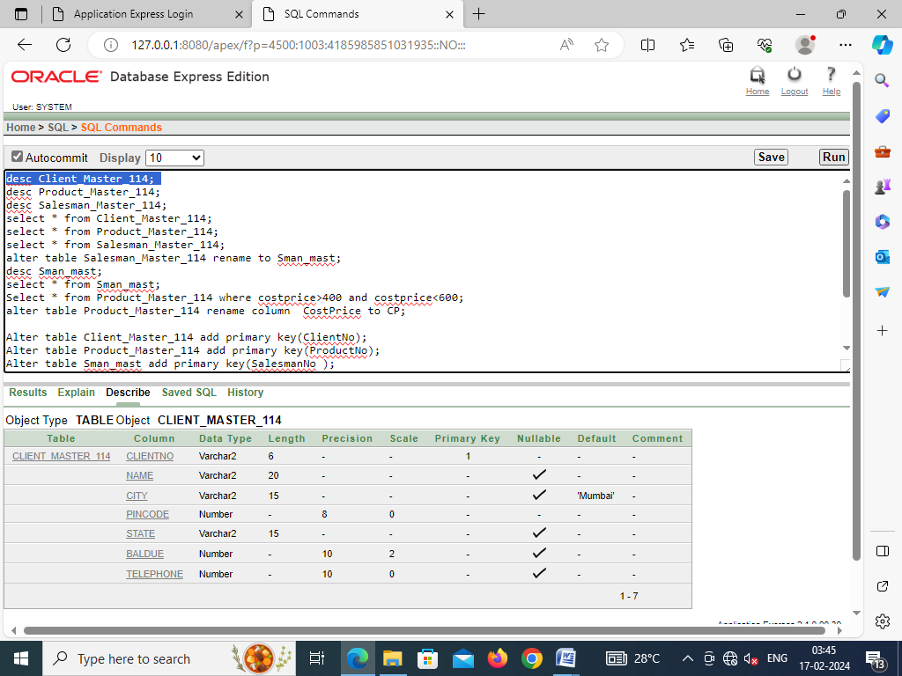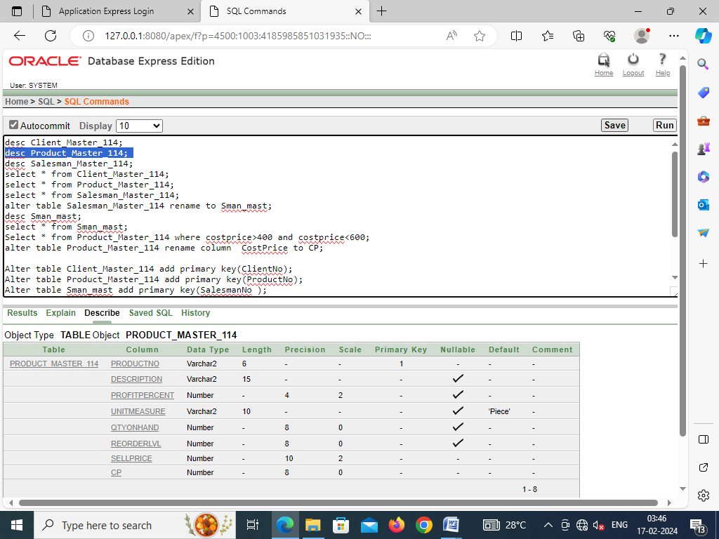

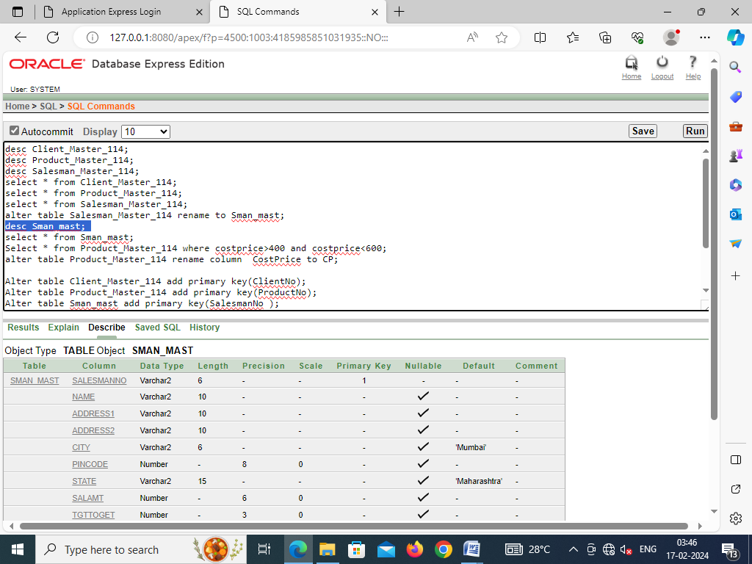

1. Remove the field “Telephone” from the Client_Master table.

Alter table Client_Master_114 drop column Telephone;

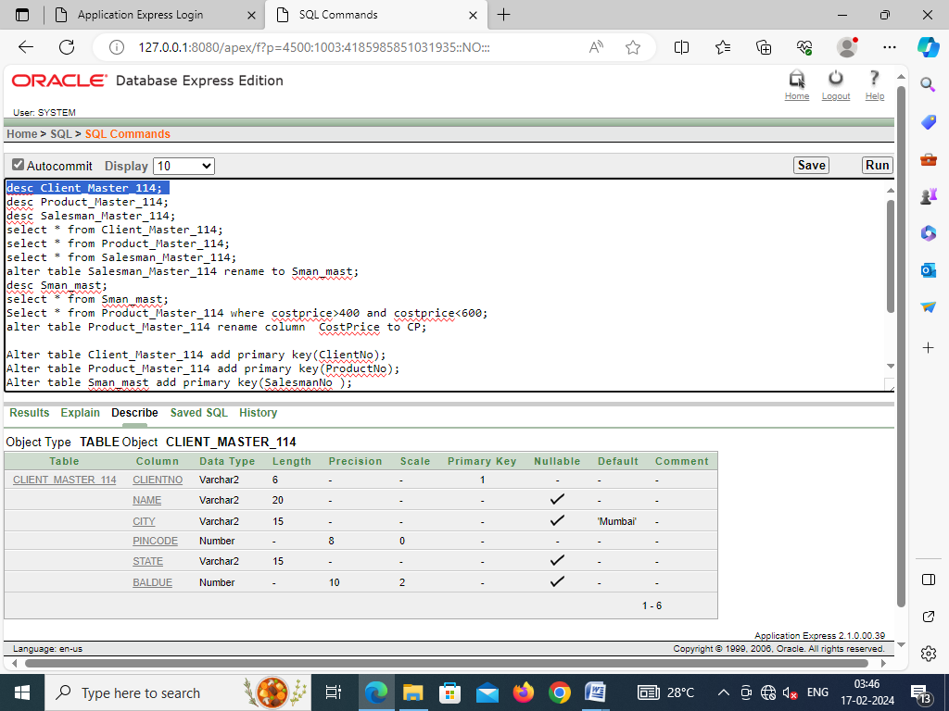

1. Truncate the table Sman_mast

Truncate table Sman_mast;

